Wilson II Printed parts guide
Extruder-direct-drive.stl  (3 pieces) | 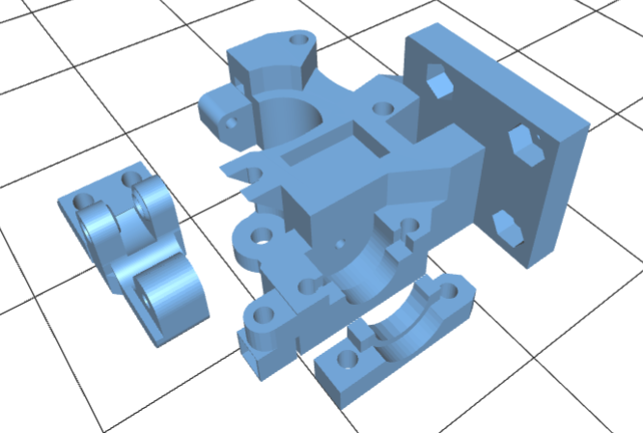
Fanduct-e3dlite6.stl | 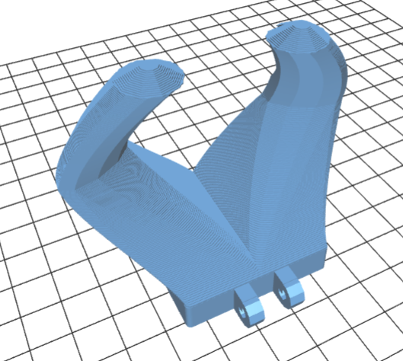
Filament-mount.stl (2 pieces) | 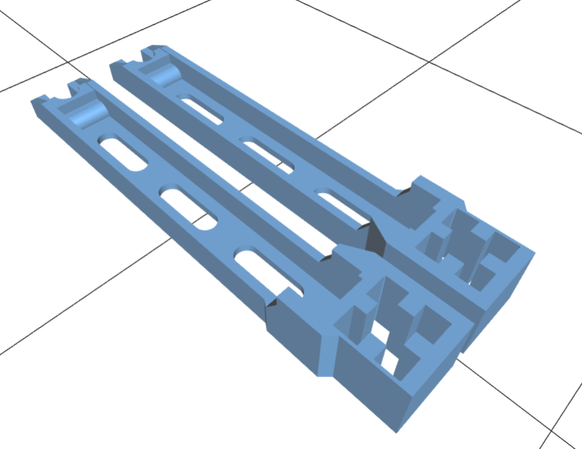
Psu-mount.stl (1) | 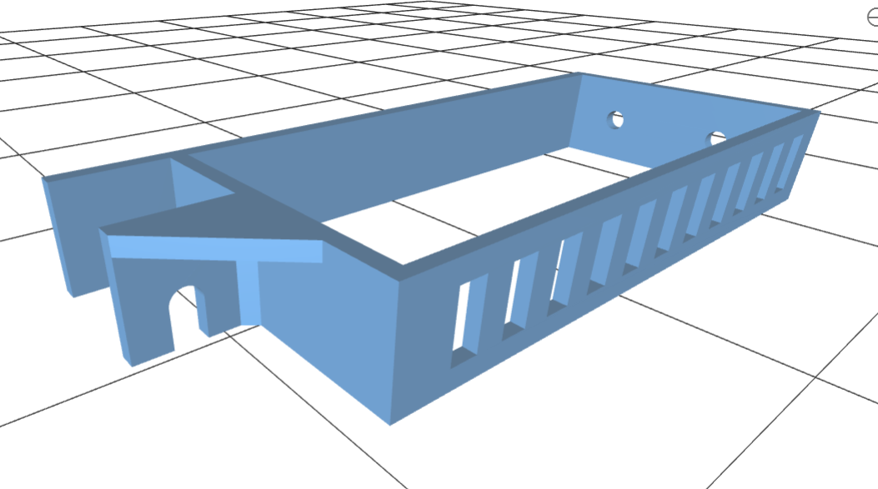
Psu-mount-bottom.stl (1) | 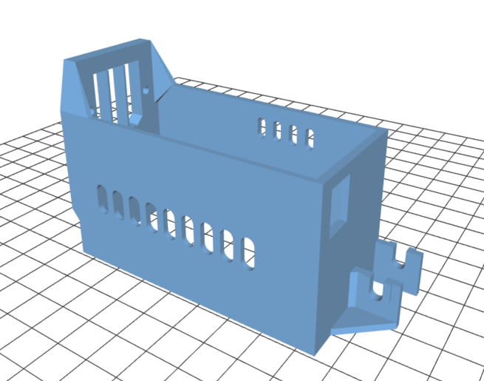
Ramps-mount.stl  (or pica-mount.stl) | 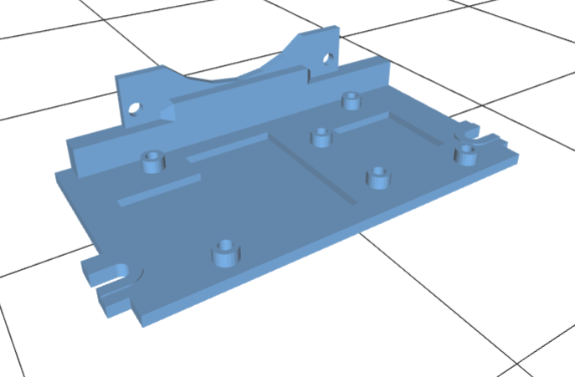
Smartlcd-mount.stl | 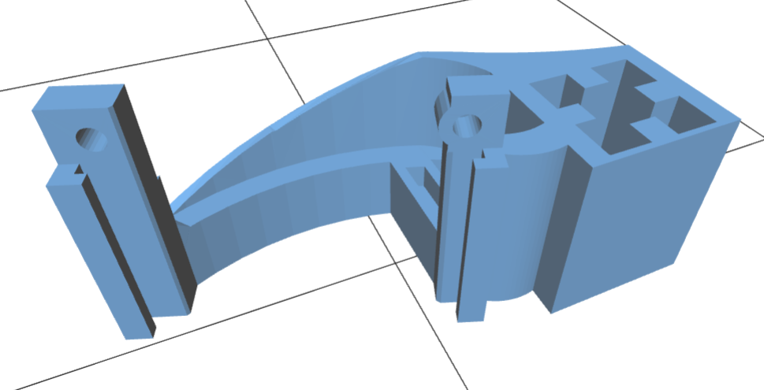
X-carriage.stl | 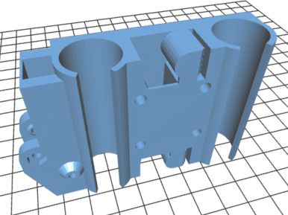
X-end-idler.stl | 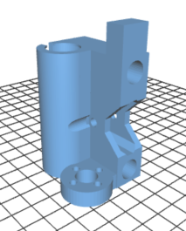
X-end-motor.stl | 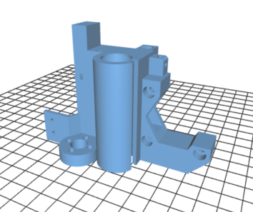
X-tensioner.stl | 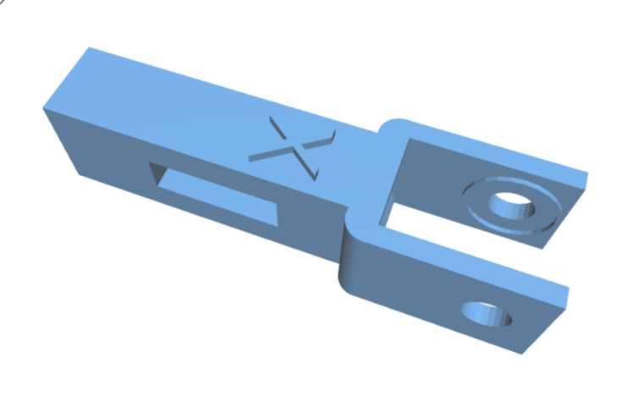
Y-brace.stl (4) | 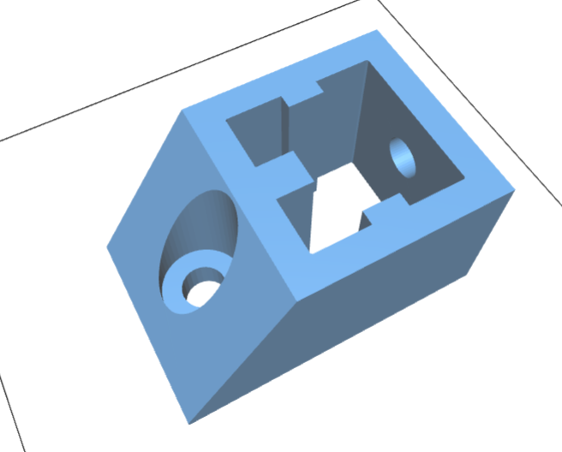
Y-idler.stl | 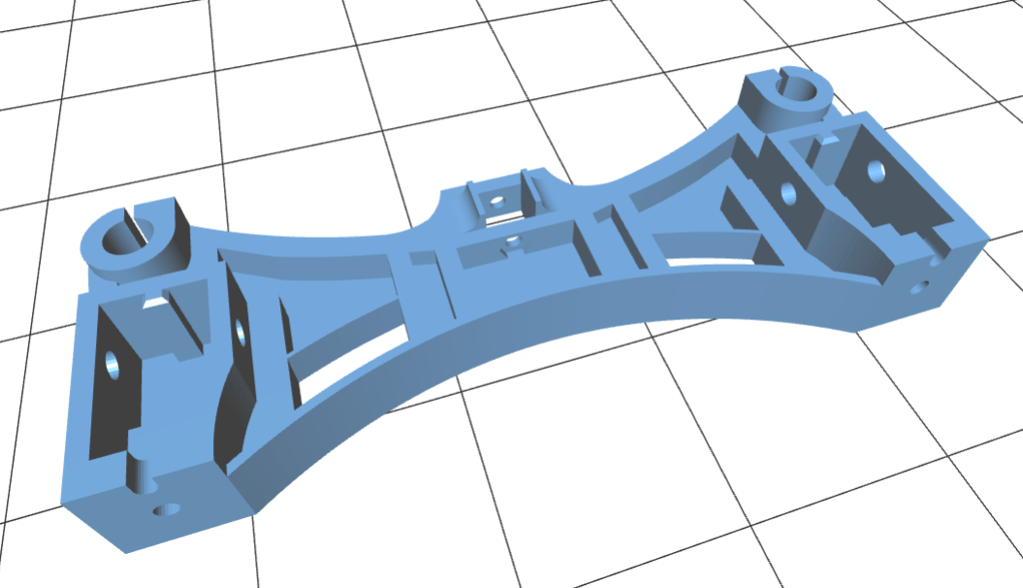
Y-motor.stl | 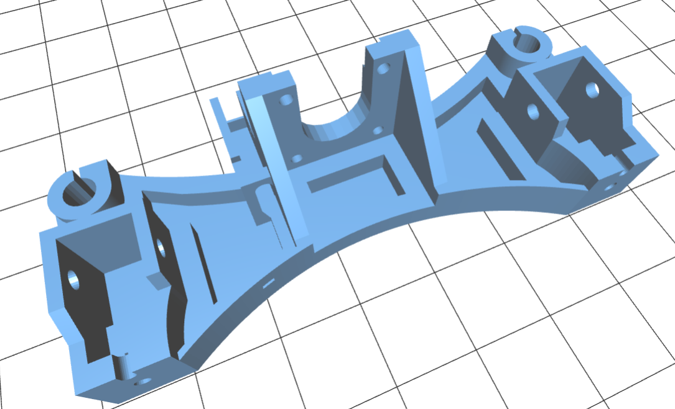
Y-table-10.stl | 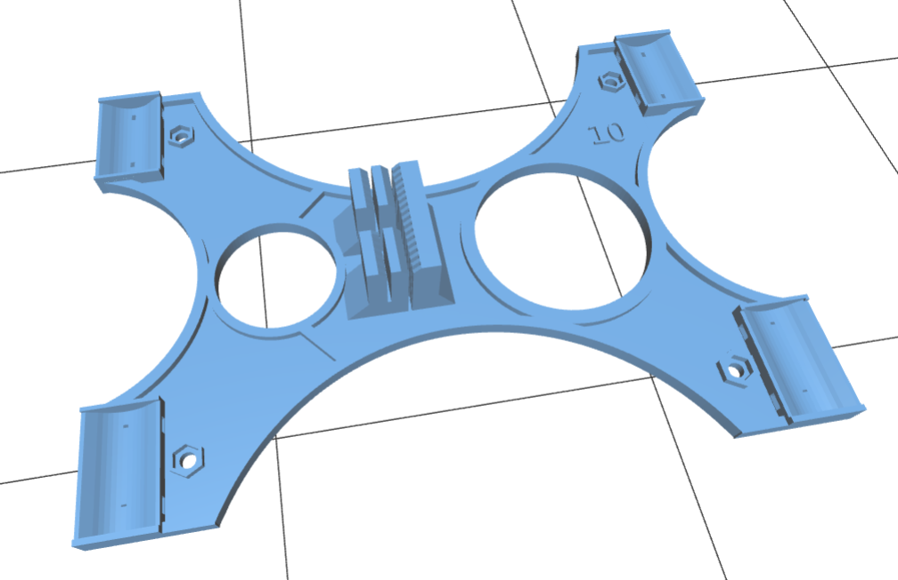
Y-tensioner.stl | 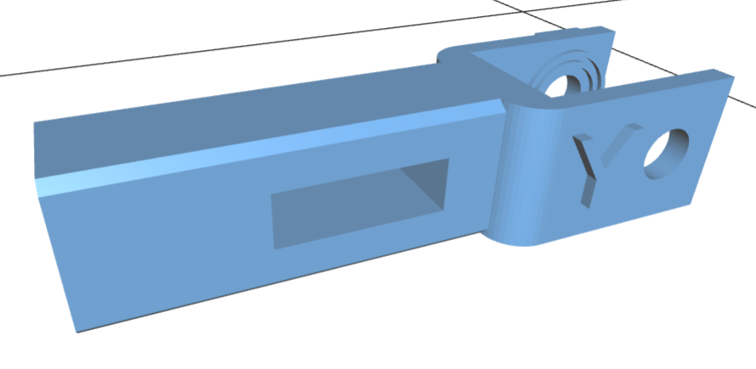
Z-lower-brace-1.stl (2) | 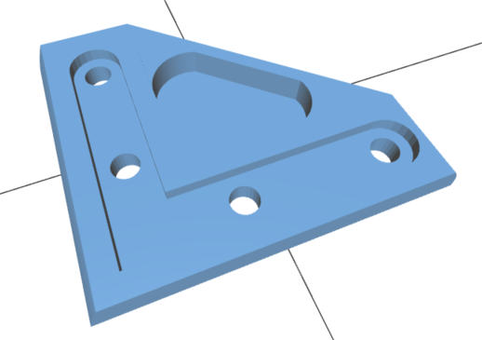
Z-lower-brace-2.stl (2) | 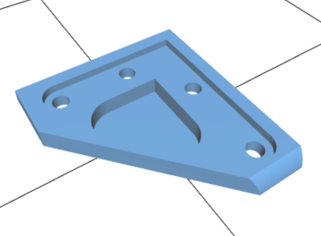
Z-motor-left.stl | 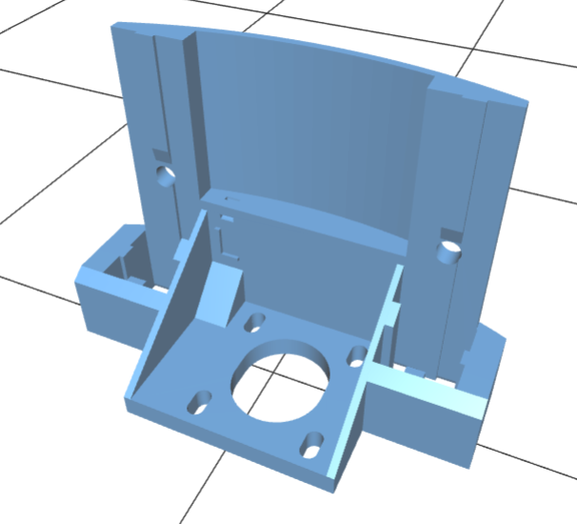
Z-pinion.stl | 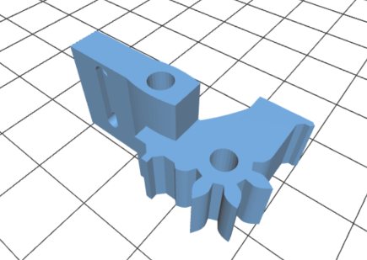
Z-motor-right.stl | 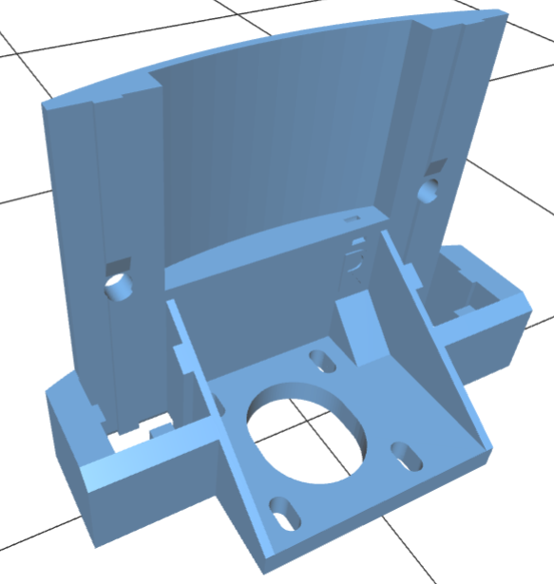
Z-top-left.stl | 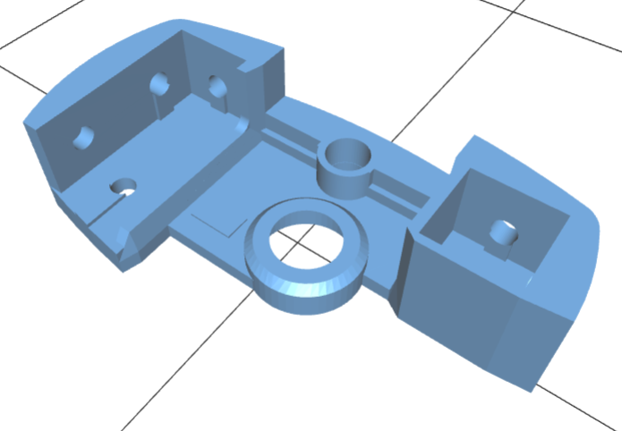
Z-top-right.stl | 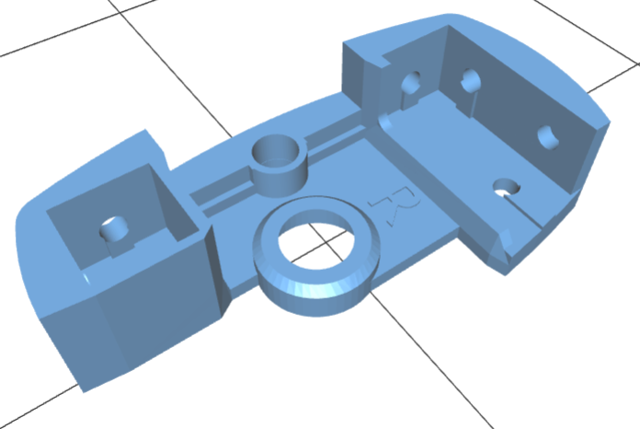
Z-rack.stl | 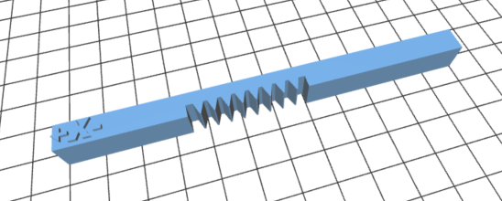
Coupler-5x8.stl (2) | 

